___________________________ _________________________ __________

School Name Grade (6-12)

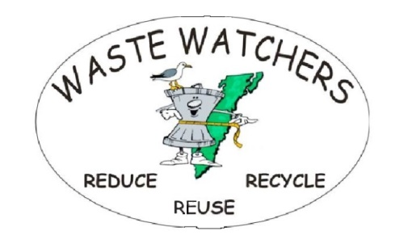[Wastewatchers.esva@gmail.com](mailto:Wastewatchers.esva@gmail.com)

Write a 30 second radio ad on the subject, “What effect does roadside litter have on the following people? How can I help change that? Choose one of the following: Farmer: Waterman: Realtor: Tourist” Just say what’s on your mind or in your heart that you want other people to hear. End it with “I’m (your name) and I’m a Waste Watcher.”

______________________________________________________________________

______________________________________________________________________

______________________________________________________________________

______________________________________________________________________

______________________________________________________________________

______________________________________________________________________

______________________________________________________________________

______________________________________________________________________

______________________________________________________________________

______________________________________________________________________

______________________________________________________________________

______________________________________________________________________

______________________________________________________________________

These materials and the activity described herein are not sponsored or endorsed by the Accomack County Public Schools.