______________________________ _________________________ __________

School Name Grade (K-5)

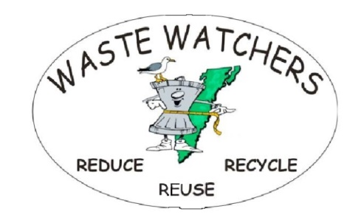[Wastewatchers.esva@gmail.com](mailto:Wastewatchers.esva@gmail.com)

Write a 30 second radio ad on the subject, “What do you think happens to the trash people throw along the road?” Just say what’s on your mind or in your heart that you want other people to hear. End it with “I’m (your name) and I’m a Waste Watcher.”

______________________________________________________________________

______________________________________________________________________

______________________________________________________________________

______________________________________________________________________

______________________________________________________________________

______________________________________________________________________

______________________________________________________________________

______________________________________________________________________

______________________________________________________________________

______________________________________________________________________

______________________________________________________________________

______________________________________________________________________

______________________________________________________________________

These materials and the activity described herein are not sponsored or endorsed by the Accomack County Public Schools.